Health & Safety Manager
Nomination | JV Company | WI Reference
 |  | WI 1100
Revision: 02 | Date of issue: 20.08.2020
Role
Support the Head of Health, Safety and Wellbeing for Area Central in the management of HSW for SCS activities, including the implementation of the H&S Management System (HSMS) to ensure compliance with OHSAS 18001:2007 certification and with Works Information. Regular liaison with other Main Works Contract and works packages to ensure sharing of best practices, innovation and continuous improvement.
The position plays the key role in helping to establish and maintain the highest and where possible, new industry Health and Safety standards for the project. The role may involve the managing of one or more direct reporting staff.

Flexible working: We welcome you to ask about the flexibility you need. This might be part-time, remote working, or compressed hours for example. Anyone who applies for a role can ask about flexibility at interview. In return, we will explore what is possible for the role.

Key Responsibilities
- Support and manage the implementation of the SCS Health, Safety and Wellbeing Strategy across Area Central.
- Understand the SCS Health & Safety Policies and Processes and statutory requirements as they affect the SCS operations and ensure that the requirements are implemented
- Provide operational and functional management advice on the practical implementation of the company’s H&S policies and processes including external stakeholders such as customers if necessary.
- Assist and provide advice to Contract Management in the understanding of stakeholders (internal and external) aims, priorities and risks with regards to H&S
- Assist, where needed, with the development of Health and Safety Management plans if applicable and coordination of review
- Provide operational and functional management with advice on the prevention of accidents, incidents and ill health
- Undertake and provide advice in key tasks to assist in the development, management, implementation and monitoring of the Health and Safety Management System
- Undertake and/ or assist Contract Management in establishing, managing and maintaining relationships with external stakeholders such as local authorities, HSE and others as required and directed
- Develop and manage program of, assist with and undertake H&S surveillance where required of operational sites. Participate, as requested in Parent Company H&S audits
- Provide advice, guidance and independence with regards to the assessment of and appointment of sub-contractors
- Assist if necessary with the preparation of H&S risk assessments and safe systems of work.
- Undertake and/ or assist with the monitoring, analysis of and reporting of H&S performance. Utilise data to highlight areas of further consideration, evaluation and intervention
- Assist and/or manage the investigation of accidents, incidents, dangerous occurrences, near misses and other incidents as directed.
- Assist in the preparation and implementation of H&S training/ briefings, as directed.
- Promote best practice, capture best practice and ensure it is fed-back into the business and parent companies
- Set standards and lead by example in the management of H&S
- Liaise with the other members of the HSS Team and the wider organisation with regards to H&S
- Maintain own level of knowledge and competency in relations to H&S Management and responsibilities including appropriate qualifications and professional membership
- Obtain competency cards in line with the SCS Competence Card Compliance Standard
- Understand the Client and Joint Venture Partners' Environment and Sustainability Policies, Processes and statutory requirements as they affect the company's operations and ensure that the requirements, as applicable within their discipline, are implemented on the project

Required qualifications, skills, behaviours and attributes
Essential
- Experience in relevant field of Construction / Infrastructure Health & Safety
- Safety, Health and Environmental Diploma, Degree or equivalent NCRQ or NVQ
- Working towards chartered membership of IOSH – CMIOSH
- Collaborative behaviours
Desired
- Institute of Leadership and Management Level 5
- Training Qualifications
In addition to the above discipline role, the Health & Safety Manager must carry out their duties in accordance with the SCS JV Core Values:
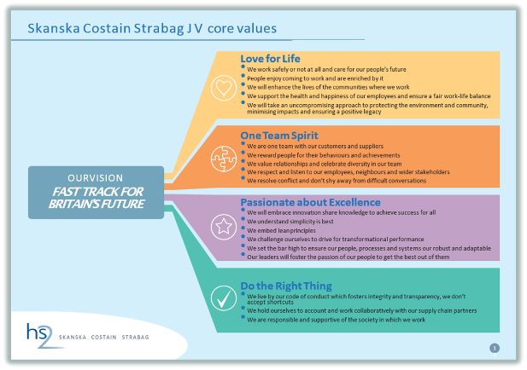
About us:
The role will work on the HS2 project. HS2 is the UK’s new high speed rail network. It will be a catalyst for economic growth across Britain, freeing up space on the existing railways and connecting 8 out of the UK’s 10 biggest cities with fast, reliable and frequent high speed services
The Skanska | Costain | STRABAG (SCS JV) is delivering the HS2 Main Civils Contracts which include both Lots S1 (Euston Tunnels & Approaches) and S2 (Northolt Tunnels). The combined value of the contracts is around £1.8billion with the works due for completion in 2025. Scope of works includes twin-bored tunnels (TBM), SCL tunnels, shaft sinking, bridge demolition and reconstruction, services diversions, earthworks and the construction of site compounds.
You’ll be a welcomed member of the wider team, with opportunities to take on additional responsibility, join one of our networks for women, military or LGBT+ staff, and participate in cultural and social events with the local community (e.g. as a STEM ambassador).
Your personal and professional development is important to us. We welcome a discussion about how we can support you with further study, or professional membership or attainment for example.
HS2 – working with Skanska, Costain and STRABAG, closely monitors job applications, to ensure an inclusive recruitment process. To ensure we are able to maintain this, and to recruit a diverse workforce, we require candidates to complete the diversity form as part of their application so we are able to monitor and improve our approach to diversity. Please note, all responses are anonymous and we will not share any of your data with other parties. All data will be held securely, (as stated within the Data Protection Act 1998) and will be reported to HS2.
We are an equal opportunity employer and value diversity at our company. We do not discriminate on the basis of race, religion, national origin, gender, sexual orientation, age, marital status, veteran status, or disability status.

